W1D2 Lab

Group members:

*\* 15. Nguyen, Ha Vu Duy  
* 20. Pham, Van ty*

**Question 1.** Comparing Algorithms

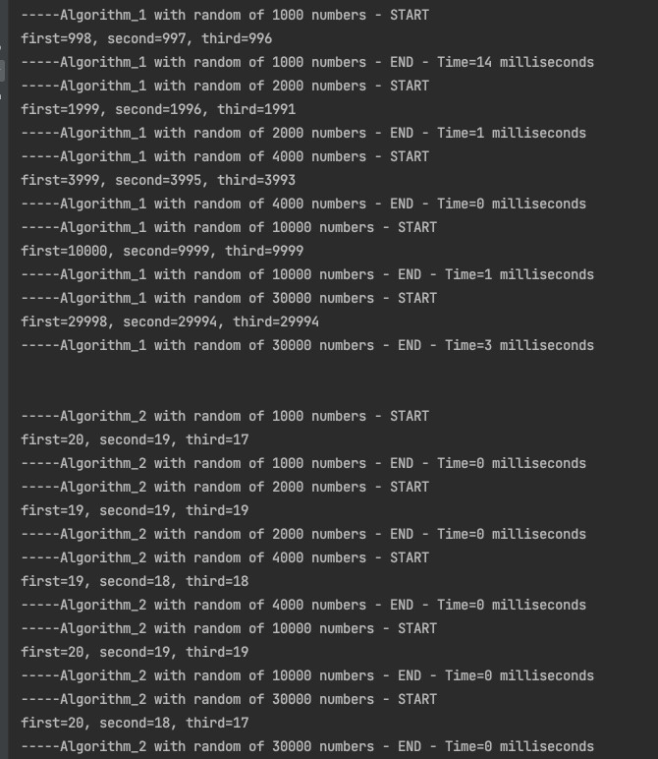

Graph:

|  |  |  |  |  |  |
| --- | --- | --- | --- | --- | --- |
|  | Random 1000 | Random 2000 | Random 4000 | Random 10000 | Random 30000 |
| Algorithm 1 | 14 | 1 | 0 | 1 | 3 |
| Algorithm 2 | 0 | 0 | 0 | 0 | 0 |

_Comparation between 2 methods to solve the problem above (data in *milliseconds*)

Conclusion:

As the above graph we can see the Algorithm_2 out-beats the Algorithm_1 in term of running time. Because Algorithm_2 just uses one loop to solve the problem with the complexity is O(n), meanwhile the Algorithm_1 uses three loops to solve the same problem.

Pseudo code & Complexity:

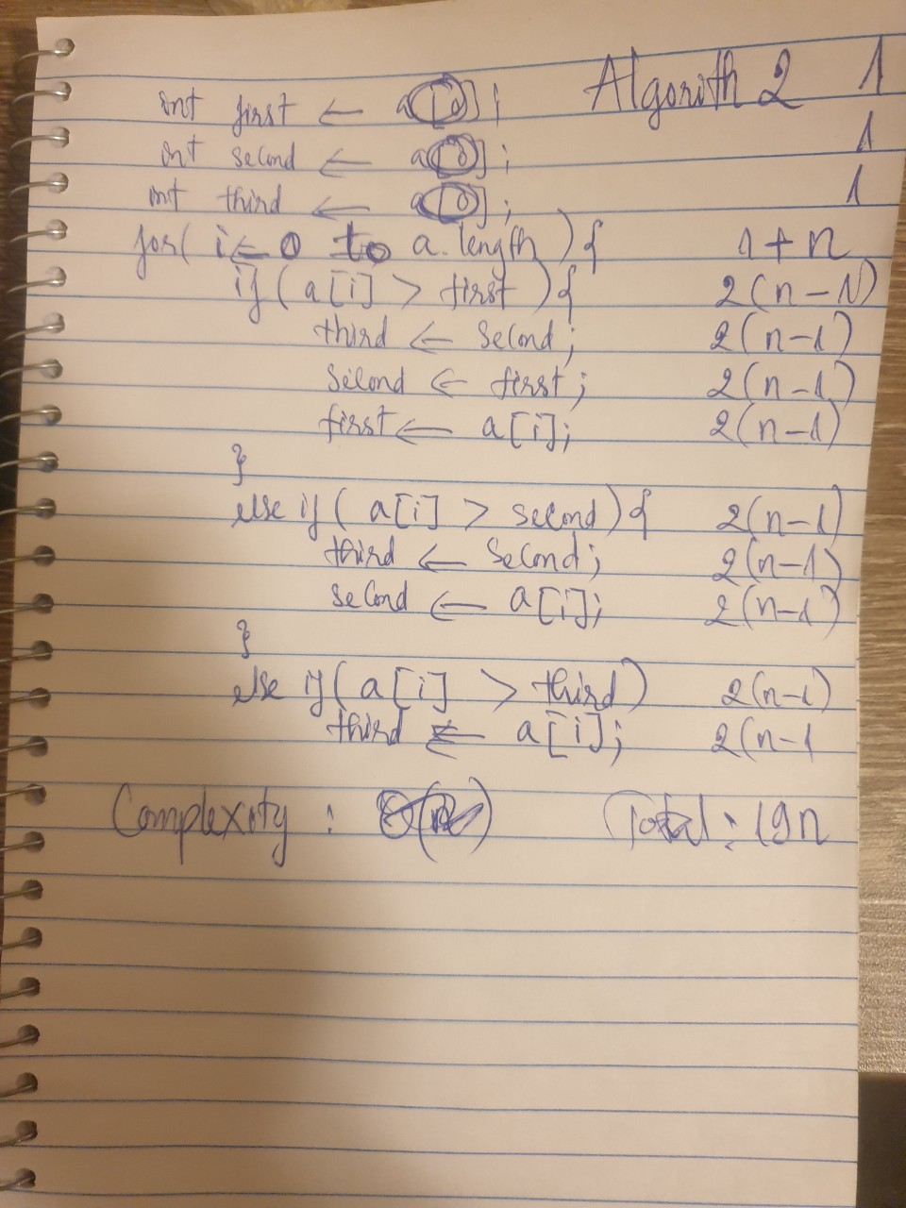

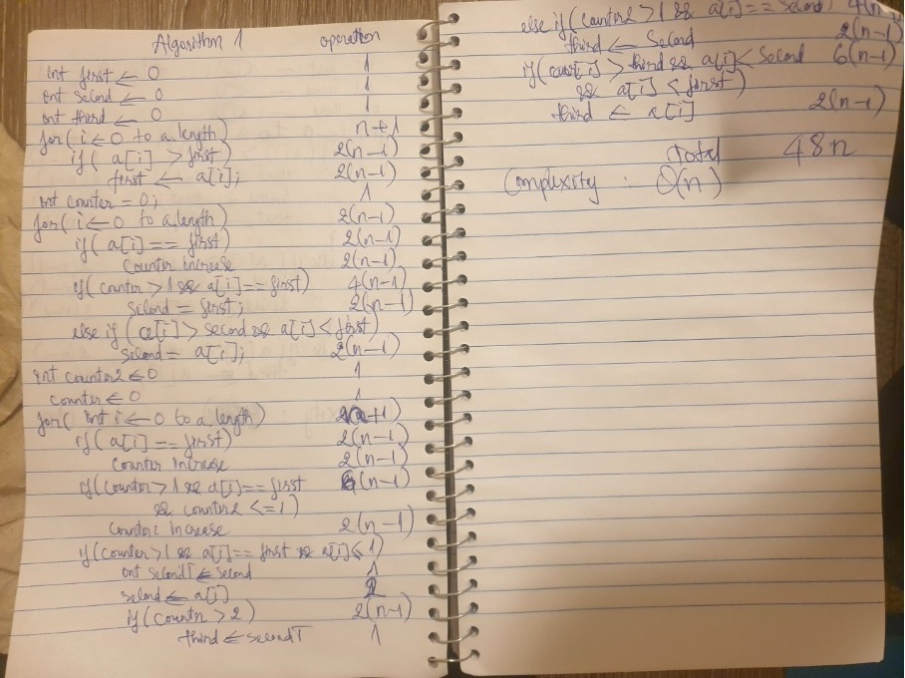

Question 2:

